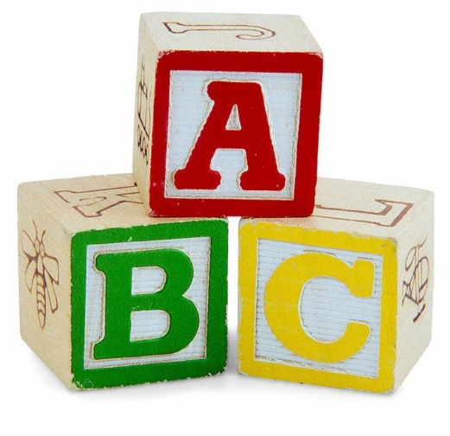
Ell-Saline Elementary
Kindergarten Round-Up

Wednesday, April 24th, 2019
Ell-Saline Elementary is making plans for the kindergarten class of 2019-2020 school year. Names of the children who will be attending are needed. Kansas State Law requires that children be five years old on or before August 31 of the year they enter kindergarten.

If you know of anyone who qualifies, PLEASE complete this form and return it. Your cooperation is appreciated.

__________________________________ _________________________________
Child’s Name Date of Birth

__________________________________
Address

__________________________________ _________________________________
Father’s Name Mother’s Name

__________________________________ _________________________________
Father’s Address Mother’s Address

__________________________________ _________________________________
Father’s Cell Number Father’s Work Number Mother’s Cell Number Mother’s Work Number

__________________________________ _________________________________
Emergency Contact 1 Relationship to Child Contact’s Cell Number Contact’s Work Number

__________________________________ _________________________________
Emergency Contact 2 Relationship to Child Contact’s Cell Number Contact’s Work Number

Please return by April 3rd, 2019
Watch for your invitation to Kindergarten Round-Up!

